GEOG 574: Lab 8 – PostGIS Tutorial II: ArcGIS and QGIS Data Integration

Nikki Jackson-Hebson

1. **129** homicides occurred within 200 feet of a subway station.

1. There are **2 census block IDs** that have the highest number of homicides per block, **both with 7 homicides.** Census block IDs: **360470259021000, 360470381002000**

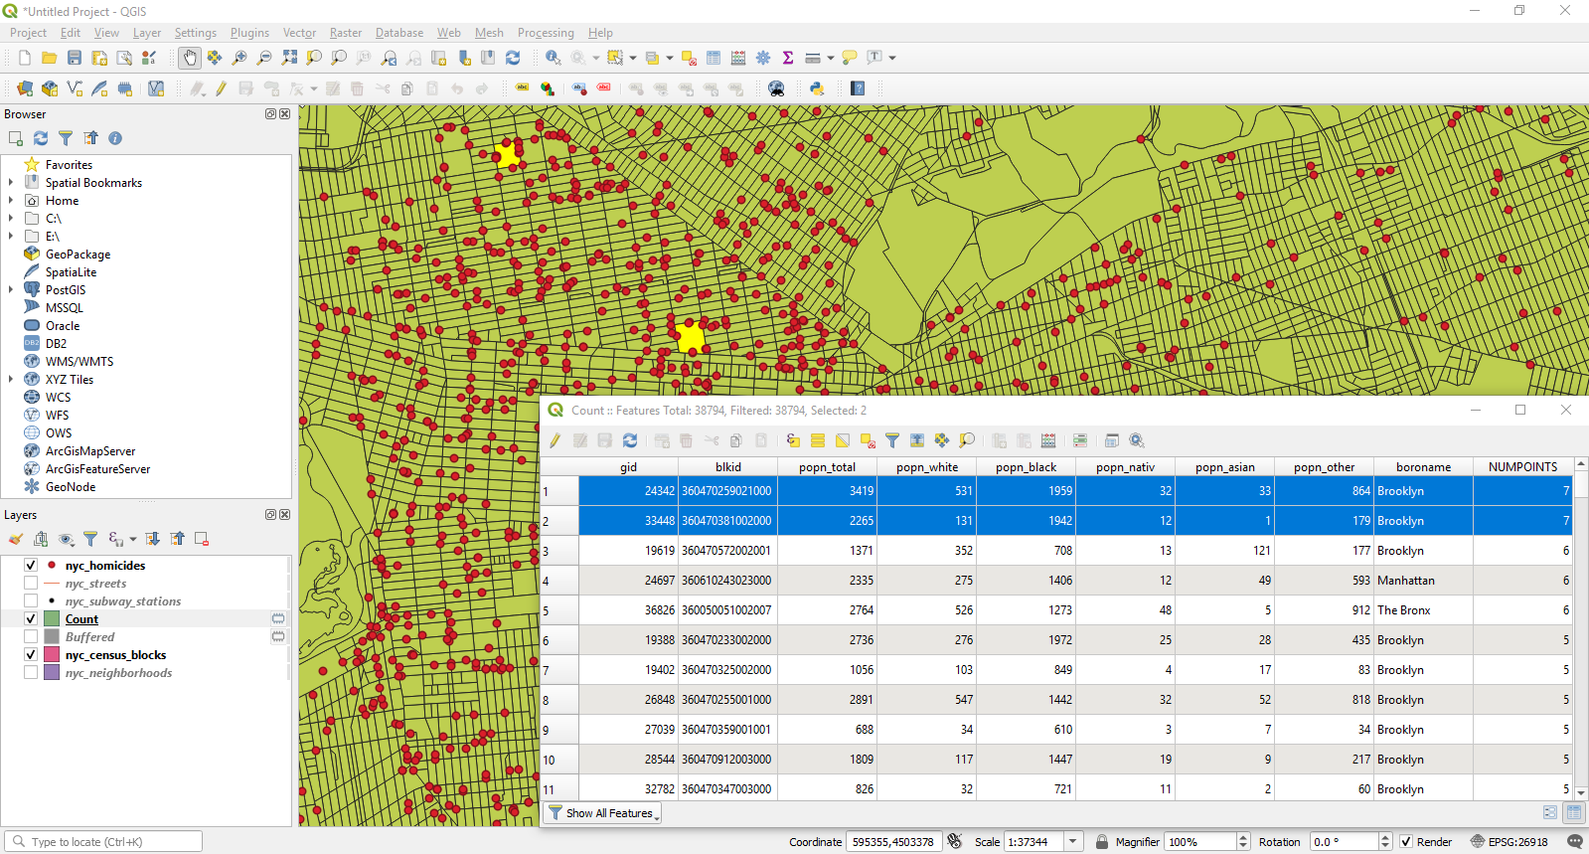

1. **126** homicides occurred within 200 feet of a subway station.

1. The neighborhood with the highest incident of homicides is **Bedford-Stuyvesant at 375 homicides**.

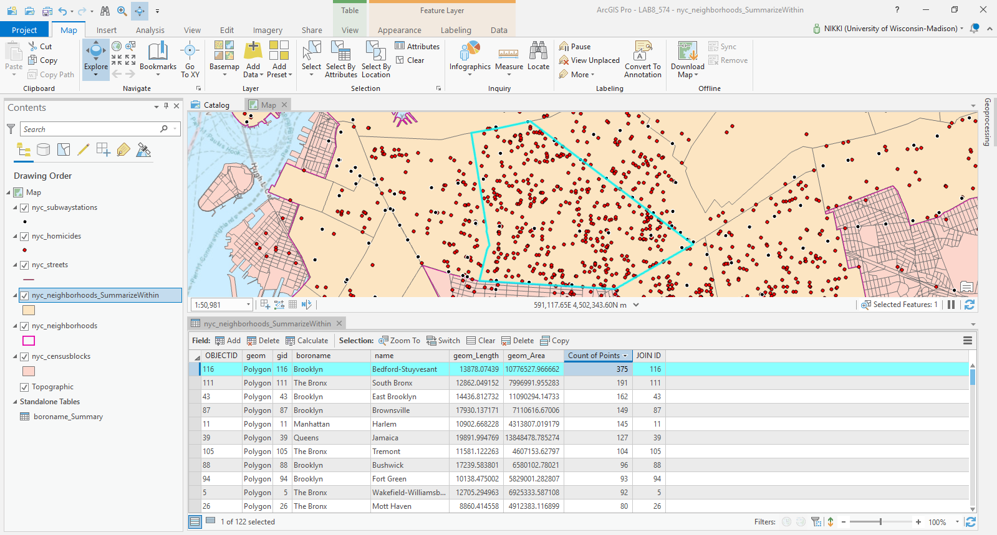

1. QGIS and ArcGIS Pro have many similarities when working with PostgreSQL and PostGIS. Both programs are relatively easy to understand and work with. All the required NYC datasets were successfully imported into both programs by following the tutorial. The SQL statements were straightforward. I did not experience any issues with either program. The differences are within the use of geoprocessing tools in QGIS and ArcGIS Pro. The tools are easy to navigate to and use, however, the added step of using the buffer tool in QGIS to find the number of homicides within 200 feet of a subway station is more time and effort for the user. I think QGIS should implement a search distance in their SELECT BY LOCATION tool like ESRI has done with their SELECT BY LOCATION tool. Also, the results in the SELECT BY LOCATION between both programs are difference. QGIS produced 129 homicides within 200 feet of a subway station while ArcGIS Pro produced 126. Otherwise, both programs were successful in completing Lab 8.